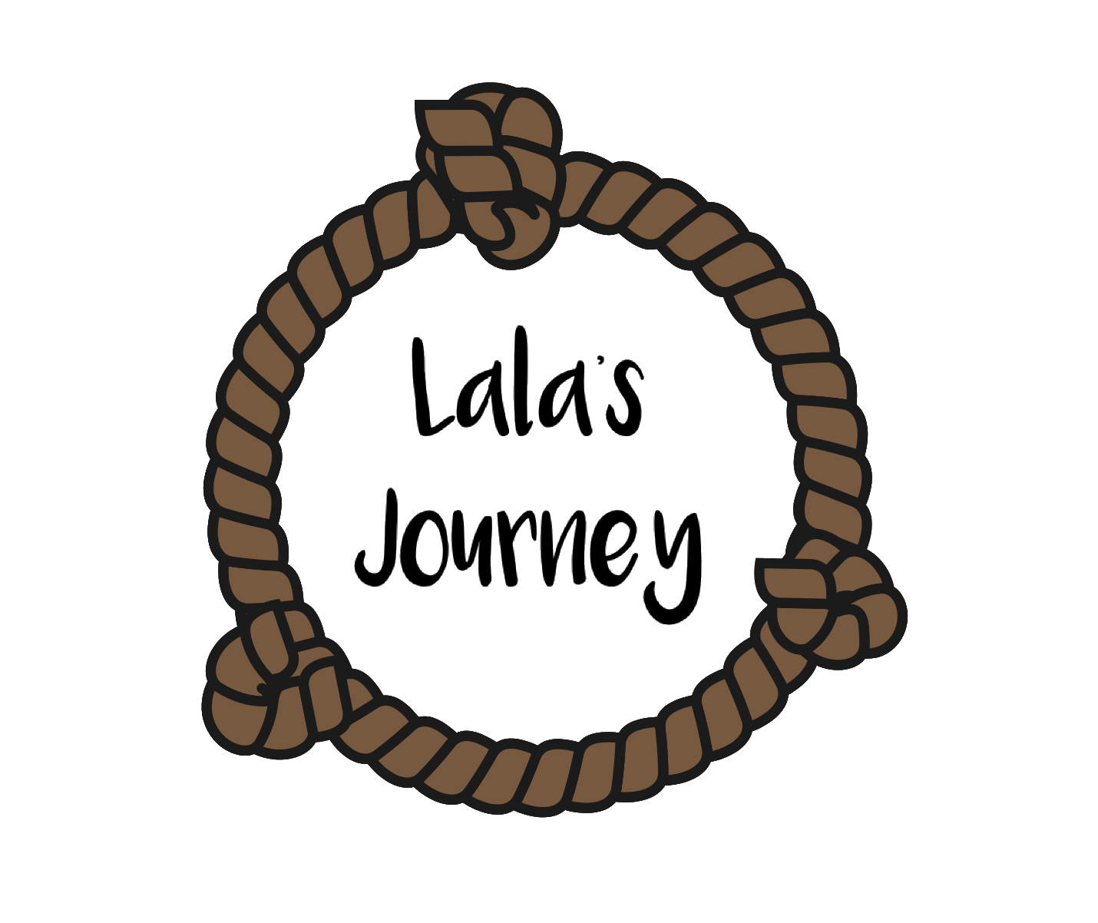

**My Notes***Training for facilitators of Lala’s Journey groups*

| MODULE 1: WHY I HELP | |
| --- | --- |
| **My Vision**  **Write down** your vision statement. (You'll refer to your vision statement later in this training, and at your team meeting.) | |
| **My expectations** for this course  What I hope to learn or accomplish: | |
| **Plan for application**  How I can keep my personal vision in mind while teaching Lala’s Journey:  What I want to learn more about my facilitation team members and their perspectives: | |
| MODULE 2: TRAUMA OVERVIEW | |
| **II. What is trauma?**  **Highlight** the words or ideas that describe the effects trauma can have on a person:  *Trauma is the experience of being overwhelmed by a threat to your life or well-being or by a threat to the life of someone you care about.*  *Sources of trauma can take many forms such as violence or accidents. It can be caused by large-scale events or by very intimate events. Trauma can also be caused by an ongoing collection of many small threats or losses, like being always on alert for danger, trying to protect your child in a displaced persons camp environment, etc.*  *Traumatic experiences trigger the body’s fight/flight/freeze response. Sometimes our bodies hold onto that adrenaline and have a hard time de-escalating.*  *To experience traumatic stress is a normal response to an abnormal experience. There’s nothing wrong – morally, spiritually, or otherwise – with a person who struggles to cope after the experience of a traumatic event.*  *-Rachel Uthmann, International Association for Refugees* | |
| The effects of trauma I have seen in people I know or have worked with: | |
| **III. Personal Resilience**  Draw or write a description of an image that represents personal resilience? | |
| **IV. The Benefits of Healthy Relationships**   1. The person who helped me through something challenging: 2. The qualities that allowed them to help me: 3. How they encouraged my resilience: | |
| MODULE 3: HOW I CAN HELP | |
| **I. The Effects of Pushing**  A time when I felt like I was pushed into sharing something more than I wanted to:  What kinds of feelings that created in me: | |
| **IV. Reflection**  What qualifications or qualities I have to offer when helping others:  What this means for my ability to make an impact in someone’s life:  My *affirmative statement* that describes my ability to help others, including my qualifications and qualities: | |
| MODULE 4: WORKING WITH CHILDREN IN TRAUMA | |
| **II. Tips for working with Children**  What I will DO it as I facilitate my Lala’s Journey group: | |
| **Tip** | **How I will implement it** |
| Children remember how you make them feel |  |
| Trust the curriculum |  |
| View behavior through the lens of trauma |  |
| “Mis-behavior” may be a response to stress |  |
| Provide structure |  |
| Set expectations for when children share |  |
| Set expectations for how children will share |  |
| Set boundaries for how children respond to one another |  |
| Allow “think time” |  |
| How practicing these tips can contribute to resilience and healthy relationships with my Lala’s Journey group: | |
| **IV. Reflection**  Name of the resource(s) I want to pursue further and how I will pursue it: | |
| MODULE 5: RESTORED RESTORERS: Part 1 | |
| **II. Ways to Care for Myself**   1. What examples of self-care have I observed or experienced? (Focuson listing what the ACTION was.) | |
| 1. **Fill in** the *Self-Care Quadrant* below to **brainstorm** ways you can care for yourself that will work especially for you.   **My Self-Care Quadrant**   | What relaxes me? | What energizes me? | | --- | --- | | What brings me joy? | When am I most fulfilled? | | |
| 1. Below is a list of self-care ideas from other participants of this course. **Add** any ideas you would like to this list.  * Exercise * Take a bath * Go for a walk * Dance * Meet with a good friend * Go for a swim * Cook a nice meal * Call a good friend * Meditate * Journal * My ideas: | |
| **III. Action Plan**  One self-care idea that is new to me that I want to try:  How I will implement it in the next few weeks: | |
| MODULE 6: RESTORED RESTORERS: Part 2 | |
| **III. Personalizing the Motivations Chart**   1. What would you add or change on the chart? 2. Suggest at least one new example of both a healthy and an unhealthy way to meet one of the desires listed. 3. What additional natural desires or motivations do you think belong on the chart? 4. Share a story that is an example of one of the other natural desires being met in a healthy way or an unhealthy way. | |
| **IV. Reflection**   1. **Facilitation Team Action Plan**  * **Imagine** that it becomes clear that someone on your team or in the organization you work through is not practicing self-care, or has an unhealthy motivation that could be hurting others. **What would you recommend that your teammates do in response?**  1. **My Motivations**  * What has the topic of healthy motivations brought to your mind that you need to take care of? * Who could you talk to? **Write** that person's name down. * **Choose** a time to call or talk to that person, and **schedule** it before continuing to the next task. | |
| MODULE 7: THE CORE ACTIVITIES OF LALA’S JOURNEY | |
| **II. The Lala’s Journey Book and Facilitator’s Guide**   * What are the major elements that are repeated in each lesson: * What I believe is the reason for those patterns: | |
| **V. Where to Go Deeper**   * Which of the 5 core activities most impacted you personally? Why? * What feelings or thoughts did these activities bring up in you? * What would you like to do about those feelings or thoughts before you teach these activities? * What is one small step you can take toward that? * When will you take that step (put it on your calendar)? | |
| MODULE 8: WHAT’S NEXT | |
| **I. Revisiting Your Vision**   * What does your vision tell you about what you are hoping for in your interaction with the children in your Lala’s Journey group? * How can you keep your personal vision in mind while working as a team facilitating a Lala’s Journey group? | |
| **II. Preparing to Set Up to Teach**  Thinking of your first Lala’s Journey group of children:   1. **Read** through the list of questions below to consider when setting up your Lala’s Journey group. 2. **Highlight** the ones that you think are a priority. (Don’t worry about answering them right now.) 3. **Underline** the ones that need outside research or input. 4. **Add** any questions you think are missing, that are important for setting up your group 5. **more?** | |
| **Set-Up Questions List**  *in preparation for your Lala’s Journey group*   1. When will we meet? 2. Where will we meet? 3. How can we make the location special? 4. How many children we will have? 5. What order do we want to have for the movable parts of the curriculum? (see front of Facilitator's Guide) 6. Who will be the facilitators (minimum 2)? 7. Who else needs to be trained to lead or help with other things, like translation? 8. What preparation meetings do we need to schedule? 9. Will we all participate in the adult version of the five activities before we facilitate? 10. When will we meet each week to prepare for the next week's lesson? (Be sure to go through the entire lesson in case there are triggers or issues to be worked out before teaching.) 11. How will we safeguard children? (i.e. what are our policies for screening volunteers, or guidelines for interacting with kids, etc.) See note below*. 12. How can we stay personally self-aware, and aware of the health of each other, and our team as a whole? 13. How will we respond to unhealthy or unbalanced motivations in caring for others? How will we communicate concerns? 14. How do we want to encourage our team to create a culture that values self-care? 15. What is our reporting structure for abuse or other issues that come up?* 16. What is our process for referring a child or family who needs professional help?** 17. Other topics or questions do you think should be addressed?   **\*Note**: This training does not cover several things asked above that are critical to have in place when working with children. You are responsible to know and implement safeguarding, and to report issues.  This is not professional, medical, or legal advice; this is meant to be informative, but we encourage you to reach out to qualified professionals in your context for more guidance. | |
| **III. Helpers’ Checklist**  **Helpers’ Checklist**   * **What are we observing among the children of our Lala’s Journey group?** * **What resources (social workers, trauma therapists, etc.) have we identified that we can seek help from?** * **What help do we need to seek for a particular child?** * **What help do I need to seek for myself?** | |
| **IV. Next Steps**  You will soon be meeting as a teaching team. You will respond to these questions at that meeting, so take time now to consider them in preparation and quickly jot down your thoughts.   1. **What strengths do we have as a facilitation team?** 2. **What roadblocks are in our way?** 3. **What can we do about them?** | |
| **V. Addressing Anxiety**  O*ne thing I am concerned about or afraid of* regarding my upcoming facilitation of a Lala’s Journey group: | |
| MODULE 9: WRAP UP | |
| **II. My To-Do List**   1. **Review** all the notes you took during this course in this document. 2. **Make** a master list below ofwhat you want to follow up on in preparation to teach your first Lala’s Journey group. | |
| **III. Reviewing Our Expectations**   * **Copy** and **paste** below the list of expectations you wrote in module 1 of this course, “Why I Help,” section III. * **Delete** the expectations that were fulfilled during the training. | |
| **My Expectations from Module 1:** | |
| 1. **What stands out to you?** 2. **Which expectations have NOT been met (those that you did not delete)?** 3. **What could you do to meet those in the coming weeks?** | |